

BAŞKENT UNIVERSITY
ELECTRIC & ELECTRONICS ENGINEERING

EEM 214 ~ ELECTRONICS–I
LABORATORY
PRELIMINARY

Experiment Name : Zener Diode Characteristics
Experiment Number : 2

Student Name : Faruk TÜRKOĞLU
Student Number :20594706
Experiment Date/Day: 02 /07 /2009

2-)

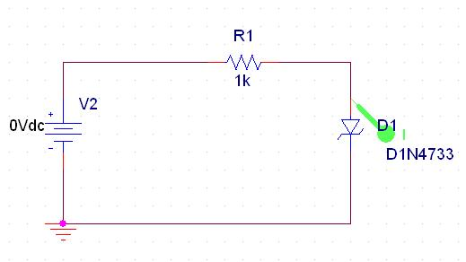

The circuit constracted in pspice,a graph of zener diodes i-v characteristic by using DC sweep analysis.(Where Vin voltage range is between –10V and 6V)

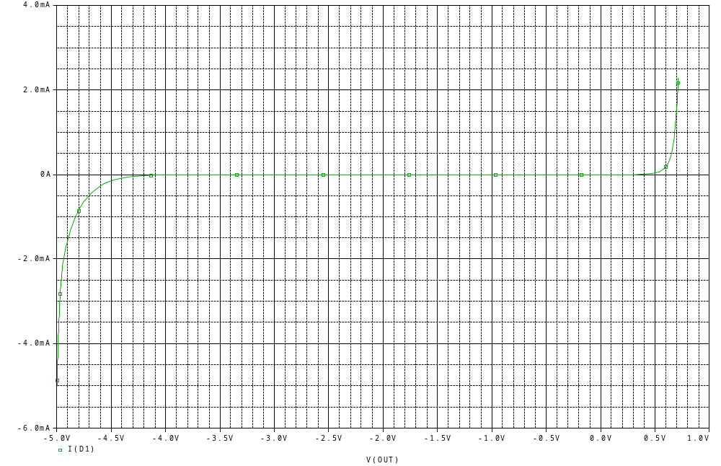
3)

A Zener diode is a type of diode that permits current to flow in the forward direction like a normal diode, but also in the reverse direction if the voltage is larger than the rated breakdown voltage or "Zener voltage".

A conventional solid-state diode will not let current flow if reverse-biased below its reverse breakdown voltage. By exceeding the breakdown voltage, a conventional diode is destroyed in the breakdown due to excess current which brings about overheating. The process is however reversible, if the device is operated within limitation. In case of forward-bias (in the direction of the arrow), the diode exhibits a voltage drop of roughly 0.6 volt for a typical silicon diode. The voltage drop depends on the type of the diode.

A Zener diode exhibits almost the same properties, except the device is especially designed so as to have a greatly reduced breakdown voltage, the so-called Zener voltage. A Zener diode contains a heavily doped p-n junction allowing electrons to tunnel from the valence band of the p-type material to the conduction band of the n-type material. A reverse-biased Zener diode will exhibit a controlled breakdown and let the current flow to keep the voltage across the Zener diode at the Zener voltage. For example, a 3.2-volt Zener diode will exhibit a voltage drop of 3.2 volts if reverse biased. However, the current is not unlimited, so the Zener diode is typically used to generate a reference voltage for an amplifier stage, or as a voltage stabilizer for low-current applications.

The breakdown voltage can be controlled quite accurately in the doping process. Tolerances to within 0.05% are available though the most widely used tolerances are 5% and 10%.

